7.

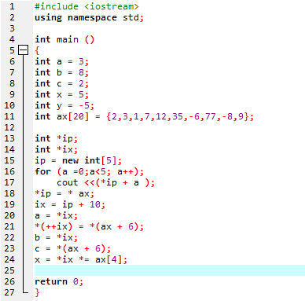

a = 11272528  
b = -6  
c = -6  
x = -72  
y = -5  
ax[6] = -6  
ax[16] = 0  
*ip = 2

8.

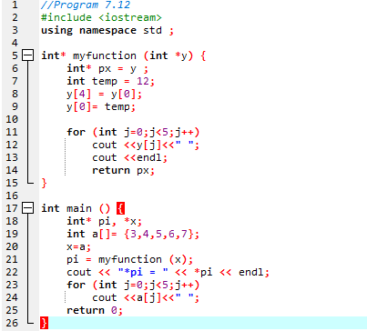

OUTPUT;

12 4 5 6 3  
*pi = 12  
12 4 5 6 3

14.

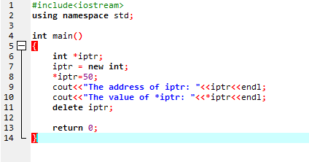

i.



ii.   
Memory layout

|  |  |  |
| --- | --- | --- |
| Memory address | Identifier | content |
| 0xca1570 | iptr | 50 |